Tutorial 3: Motion

1. (i) What are the two limitations in using optical flow methods for motion analysis?
- Give an example of a scenario which gives rise to a zero motion field everywhere but a non-zero optical flow field.
- Give an example of a scenario which gives rise to a non-zero motion field everywhere but a zero optical flow field.

- There is an editing technique in cinematography known as a “dissolve”. This is a gradual transition from one scene to another, in which the first scene fades out and the second scene fades in. An example is given in the Figure below, where the “dissolve” technique is used to effect a gradual transition from the elephant shot to the landscape shot. Explain what would happen if optical flow is extracted from this sequence of frames.
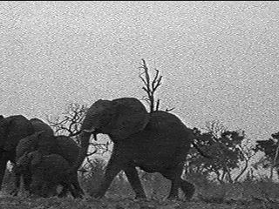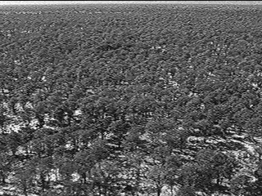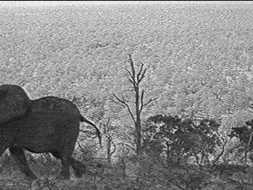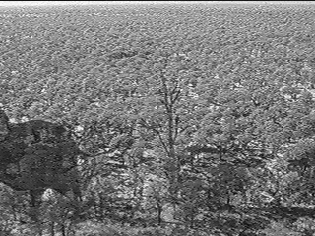

- (i) Sketch the optical flow field in the situation where the camera is moving directly towards a textured wall at a constant velocity. Also, does the motion flow field change over time in this situation? If so, how? If not, why not?

(ii) Suppose we have a camera that is undergoing a purely translational motion, and that the camera, with a focal length of 200 pixel unit, is moving with velocity (U,V,W) = (-20, 30, 50). What is the location of the focus of expansion for this particular motion? Suppose that the entire scene in view is a ground plane (i.e. a flat ground receding towards the horizon), draw a diagram to illustrate the pattern of the optical flow vectors for this type of motion and scene.

4. (i) When we perform a 3D reconstruction from motion flow, we can only ever determine the structure up to an unknown scale factor. Explain why it is so?

(ii) Can scaled scene depths be recovered from a pair of images taken at different times by a single (perspective projection) camera rotating about its optical center?

- Given focal length f =1, and that the rotation is of the form ω = (α, 0, 0). The optical flows at the following three feature points (1, 0), (0, 1), (1, 1) are given respectively by (1, 0.1), (0, 1.2), (1.1, 1.2). For the two FOE candidates (x₀, y₀) = (0, 0) and (x₀, y₀) = (∞, 0),
- write down for the three feature points the respective unit vectors along which there is no translational flow.
- write down the least square system of equations to solve α.
Which is the better FOE candidate?

